Chip back potential is the level which bulk silicon is maintained by on-chip connection, or it is the level to which the chip back must be connected when specifically stated below. If no potential is given the chip back should be isolated.

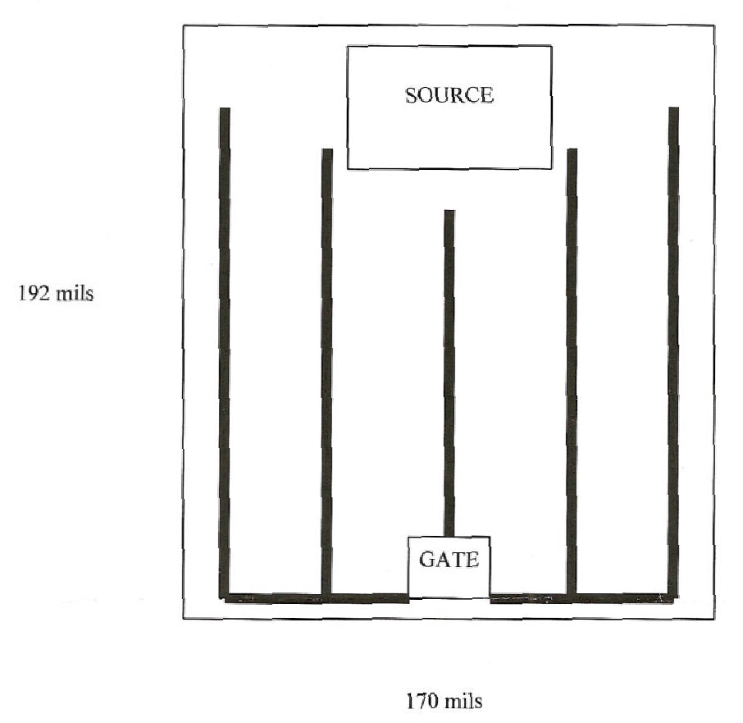

CHIP BACK IS DRAIN

Top Material: Al
Backside Material: CrNiAg
Bond Pad Size: S = .042” X .060” G = .018” X .025”
Backside Potential: Drain
Mask Ref: Hex-4 100V GEN III

APPROVED BY: DK DIE SIZE .170” X .192” DATE: 7/11/22
MFG: IR THICKNESS .016” P/N: IRFC140
DG 10.1.2

Rev B, 7/19/02

